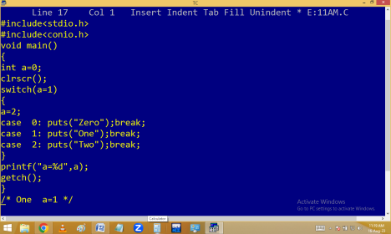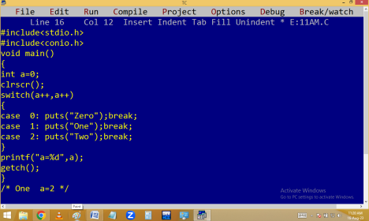
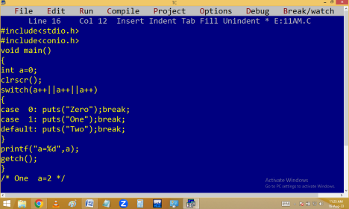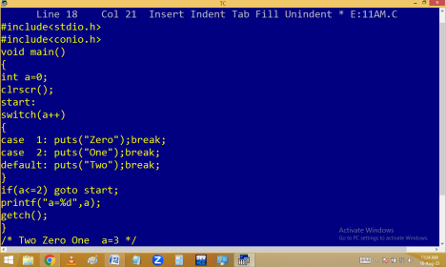
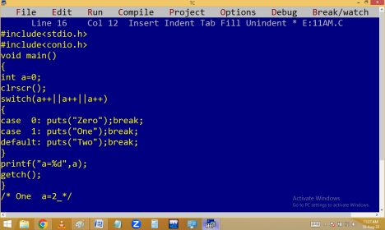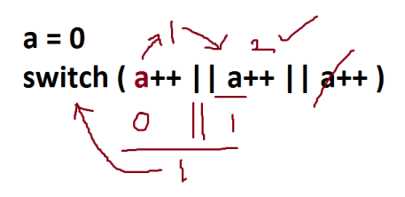
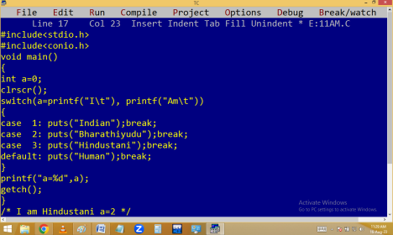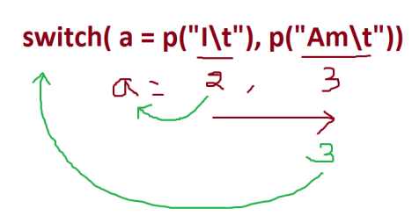
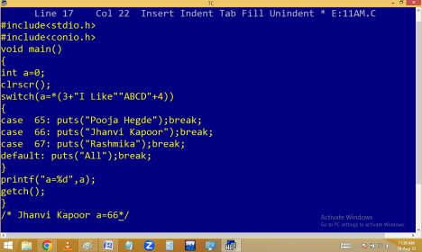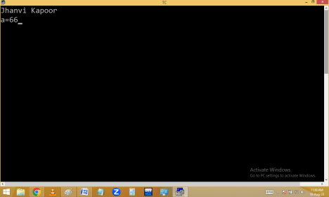
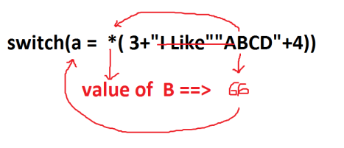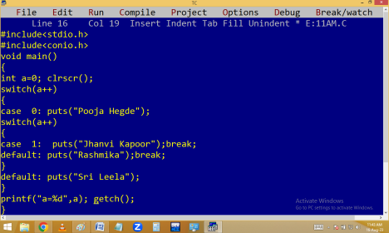
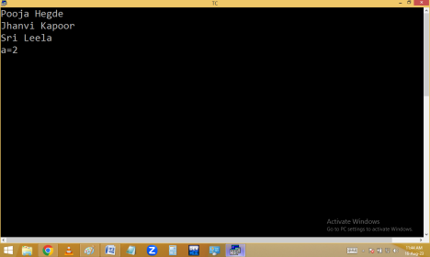
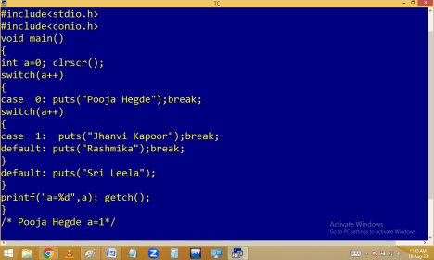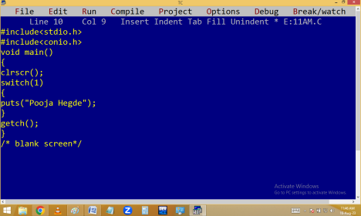
Finding even/odd using switch:
Eg. Finding weekday name using switch:
Finding vowel / consonant using switch:
Using predefined functions:
Hotel Bill preparation using menu:
#include<stdio.h>
#include<conio.h>
void main()
{
int op;
float qty, price, amt=0;
start:
clrscr();
puts("-------------------------------------------------------------------------- ");
puts("\t\t\t HOTEL SAI BALAJI");
puts("\t\t\t AMEERPET");
puts("-------------------------------------------------------------------------- ");
puts("\t\t\t M E N U");
puts("-------------------------------------------------------------------------- ");
puts("\t\t 1. Tea - 10/-");
puts("\t\t 2. Coffee / Boost / Horlicks / Water bottle - 20/- ");
puts("\t\t 3. Idly / Bonda/ Plain Dosa- 30/-");
puts("\t\t 4. Karam / Masala / Onion / Ghee dosa / Wada - 40/-");
puts("\t\t 5. Poori / Chapathi / parota - 50/- "); puts("\t\t 6. Veg Biryani - 60/-");
puts("\t\t 7. Bill");
puts("\t\t 8. Cancel");
puts("\t\t 9. Exit");
puts("-------------------------------------------------------------------------- ");
printf("\t\tEnter ur option[ ]\b\b");
scanf("%d",&op);
if(op==8)amt=0;
else if(op==9)return;
else if(op==7){printf("Ur bill = %.2f",amt);amt=0;} else
{
printf("Enter Quantity "); scanf("%f",&qty);
switch(op)
{
case 1: amt+=qty*10;break; case 2: amt+=qty*20;break; case 3: amt+=qty*30;break; case 4: amt+=qty*40;break; case 5: amt+=qty*50;break; case 6: amt+=qty*60;break; default: puts("Item not available");
}
}
getch();
goto start;
}

